DATA ANALYST Assignment – 4

# Task – 1

**Fixed LOD Expression:** In Tableau, a fixed level of detail (LOD) expression calculates a value using specified dimensions, without reference to the view's dimensions or filters.

**Calculation** - { FIXED [Category]:SUM([Sales])}

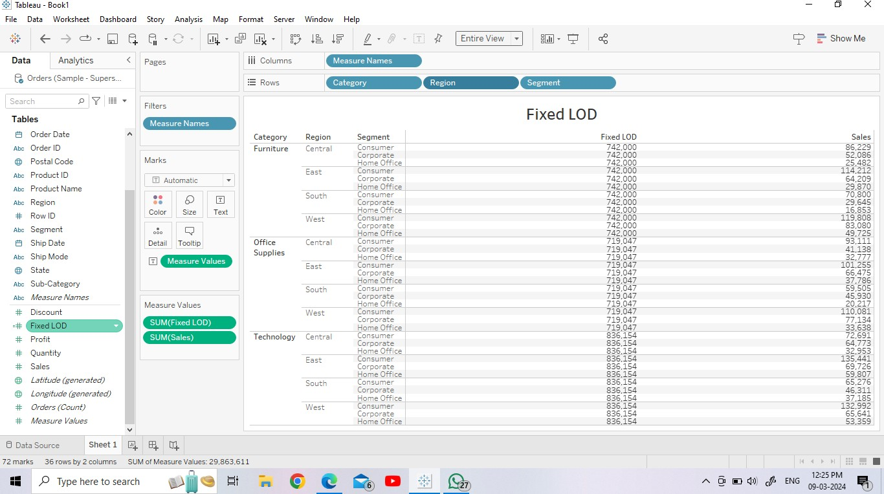

**Exclude LOD Expression:** In Tableau, EXCLUDE level of detail (LOD) expressions prevent calculations from using one or more dimensions in the view. EXCLUDE LOD expressions work by excluding a specific dimension or set of dimensions from the calculation, while still considering the other dimensions present in the view.

EXCLUDE LOD expressions are useful for scenarios like "percent of total" or "difference from overall average". For example, to see the average blood pressure for each country over time without splitting by sex, use the expression (EXCLUDE (Sex) : AVG(Average blood pressure))

**Calculation -** { EXCLUDE [Sub-Category]:SUM([Profit])}

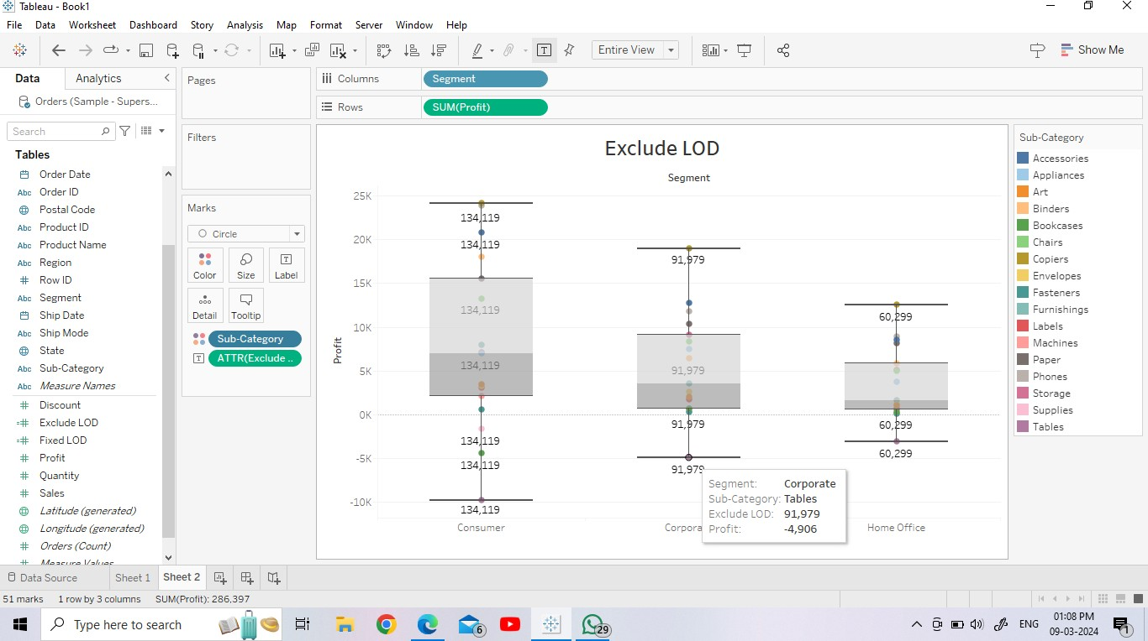

# Task – 2

**Map Visualizations:** Map visualization is used to analyze and display the geographically related data and present it in the form of maps. This kind of data expression is clearer and more intuitive. We can visually see the distribution or proportion of data in each region

## Map – 1 African states with profit

Here the visualization is generated by geographical data, and here the exhibited data is the profit of each and every state of Africa. The color element is used for better understanding and easy recognization of each state .

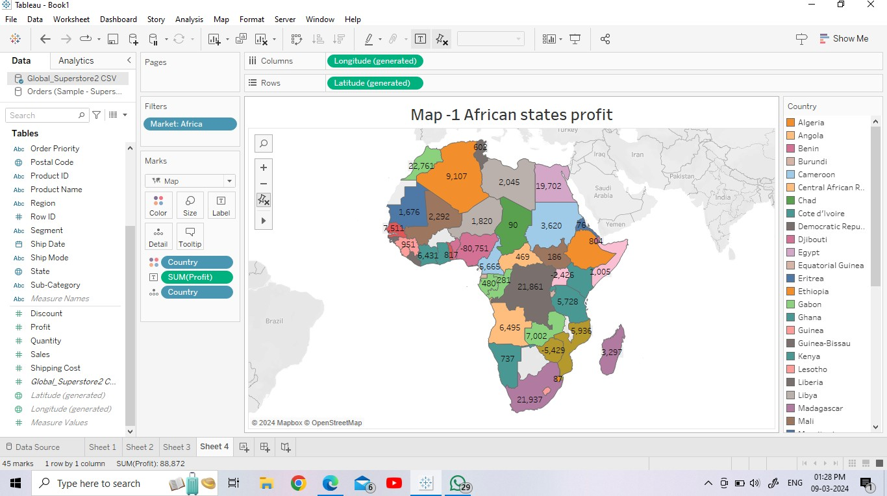

## Map – 2 Indian states with categorical sales

Here the visualization is generated by geographical data, and here the exhibited data is the profit of each and every state of India. The color element is used for better understanding and easy recognization of each state . The sales of different categories has been visualized here.

The latitude and longitude measures are also taken into consideration to plot India in entire world map and the sum of sales, category , country and state are the respective measures and dimensions which are used in this visualization.

Filters are also used here to obtain India from the World map.

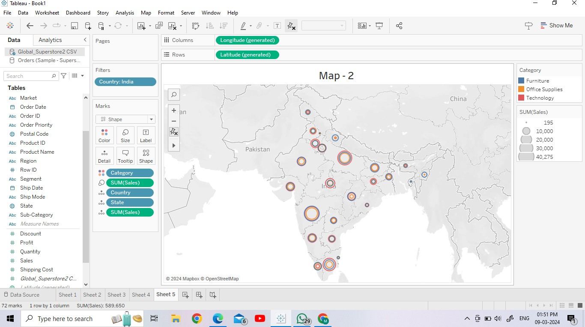

# Task – 3

**Top N Parameter :** A Top N parameter in Tableau is a parameter that allows users to choose how many dimension members to display. This feature is called the Top N% filter.

In Tableau, a Top N parameter is a value that the user selects to return data according to a number. The "N" in the name refers to the number. For example, if a company has 1,000 products and wants to see the top five, they can use a Top N filter.

## Top 5, 10, 15 sub categories

Here top 5, 10, 15 sub categories with maximum sales and the bars are used to represent it visually.

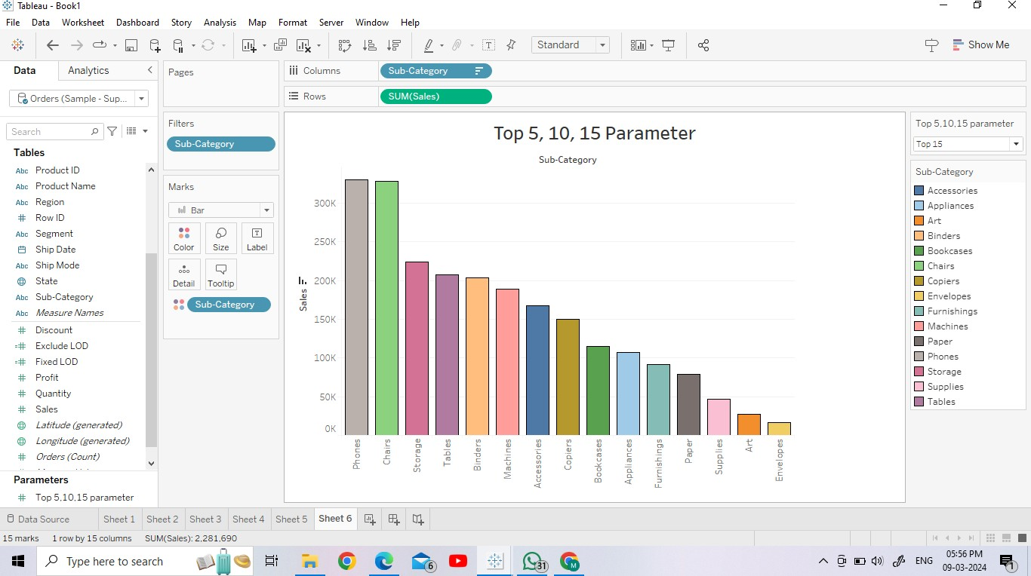

**Dimensional Parameter :** A dimension parameter

allows you to

identify dimensions in a geometry project and assign a variable to the dimension, which allows you to vary those dimensions within an analysis.

**Using parameters to dynamically display dimensions in Tableau**

1. Create a parameter. Create a new parameter that lists your dimensions of interest. ...
2. Create a calculated field. The next step is to create a calculated field that will be used as a dimension in your worksheet. ...
3. Add the calculated field to the canvas.

**Calculation -** IF [Dimensional Parameter] =" category" THEN[Segment] ELSEIF [Dimensional Parameter] ="Sub category" THEN[Category] ELSEIF [Dimensional Parameter]="segment" THEN[Sub-Category]

END

